Archives of Maryland
(Biographical Series)
E. Paul Mason (1891-1968)
MSA SC 3520-14352
59th President of the Bar Association of Baltimore City 1937-1938
Associate Judge of the Supreme Bench of Baltimore City 1944-1961
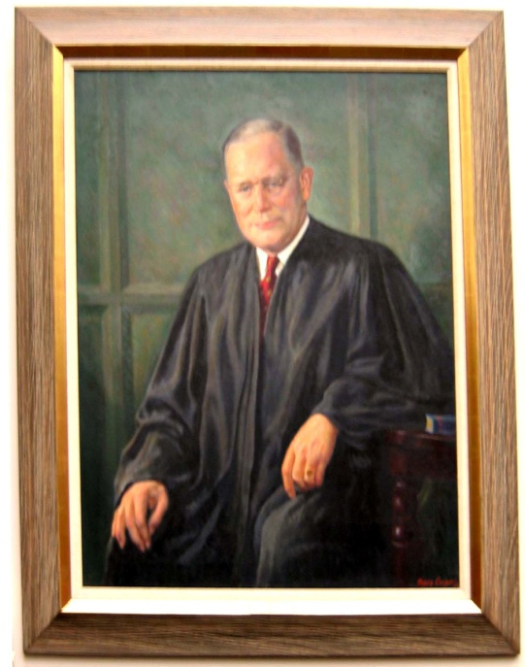
Biography | Images
Sources | Related  Collections

Source: Baltimore City Circuit Court Collection
Artist: Henry Cooper (1907- )
Date: 1969
This information resource of the Maryland State Archives is presented here for fair use in the public domain. When this material is used, in whole or in part, proper citation and credit must be attributed to the Maryland State Archives. PLEASE NOTE: Rights assessment for associated source material is the responsibility of the user.

Tell Us What You Think About the Maryland State Archives Website!

[ Archives' Home Page || All About Maryland || Maryland Manual On-Line || Reference & Research
|| Search the Archives || Education & Outreach || Archives of Maryland Online ]
Governor General Assembly Judiciary Maryland.Gov
© Copyright October 27, 2005 Maryland State Archives

Archives of Maryland
(Biographical Series)
E. Paul Mason (1891-1968)
MSA SC 3520-14352
59th President of the Bar Association of Baltimore City 1937-1938
Associate Judge of the Supreme Bench of Baltimore City 1944-1961
Biography:
Born in Baltimore, Maryland, 1891. Attended Baltimore public schools; University of Maryland Law School. Admitted to the Bar, December 22, 1915. Married, Florence Mercer, 1915; two children, E. Paul Mason, Jr., and Mrs. John R. Crunkleton, Jr. Died, Baltimore, July 26, 1968.
After graduating from the University of Maryland Law School, E. Paul Mason served as President of the Bar Association of Baltimore City from 1937-1938. He was also the President of the Barristers Club, where he helped establish modern system of medical examiners. Appointed to the Supreme Bench of Baltimore City, October, 1944, Judge Mason was known as "Maximum Mason" for the harsh sentences he often handed down. He served until November 5, 1961, working to keep politics separate from the judiciary, and lessening his harsh sentences towards the end of his career. He also held positions as the Maryland representative for the National Commission for the Promotion of Uniformity of Legislation, a member of the House of Delegates for the American Bar Association, and President of the Board of Trustees at First Baptist Church, at University and 34th Street, where his funeral was held in 1968.
Return to E. Paul Mason's Introductory Page

This information resource of the Maryland State Archives is presented here for fair use in the public domain. When this material is used, in whole or in part, proper citation and credit must be attributed to the Maryland State Archives. PLEASE NOTE: Rights assessment for associated source material is the responsibility of the user.

Tell Us What You Think About the Maryland State Archives Website!

[ Archives' Home Page || All About Maryland || Maryland Manual On-Line || Reference & Research
|| Search the Archives || Education & Outreach || Archives of Maryland Online ]
Governor General Assembly Judiciary Maryland.Gov
© Copyright August 12, 2005 Maryland State Archives

Archives of Maryland
(Biographical Series)
E. Paul Mason (1891-1968)
MSA SC 3520-14352
59th President of the Bar Association of Baltimore City 1937-1938
Associate Judge of the Supreme Bench of Baltimore City 1944-1961

Sources:
"Judge E. P. Mason Dies at age of 73." Baltimore Sun 27 July 1968.
Return to E. Paul Mason's Introductory Page

This information resource of the Maryland State Archives is presented here for fair use in the public domain. When this material is used, in whole or in part, proper citation and credit must be attributed to the Maryland State Archives. PLEASE NOTE: Rights assessment for associated source material is the responsibility of the user.

Tell Us What You Think About the Maryland State Archives Website!

[ Archives' Home Page || All About Maryland || Maryland Manual On-Line || Reference & Research
|| Search the Archives || Education & Outreach || Archives of Maryland Online ]
Governor General Assembly Judiciary Maryland.Gov
© Copyright August 12, 2005 Maryland State Archives
Archives of Maryland
(Biographical Series)
E. Paul Mason (1891-1968)
MSA SC 3520-14352
59th President of the Bar Association of Baltimore City 1937-1938
Associate Judge of the Supreme Bench of Baltimore City 1944-1961
Images:
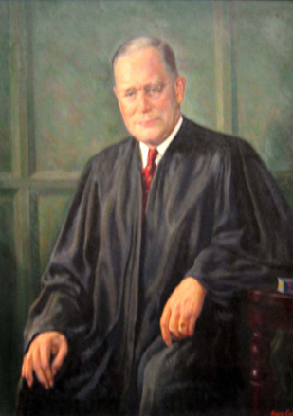
Source: Baltimore City Circuit Court Collection
Artist: Henry Cooper (1907- )
Date: 1969
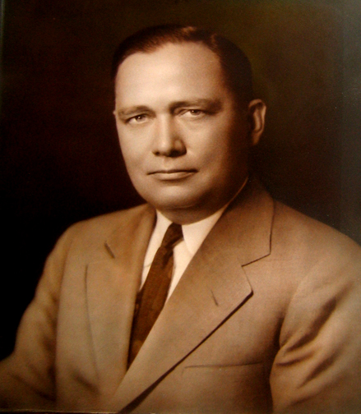
Source: Baltimore City Circuit Court Collection
This information resource of the Maryland State Archives is presented here for fair use in the public domain. When this material is used, in whole or in part, proper citation and credit must be attributed to the Maryland State Archives. PLEASE NOTE: Rights assessment for associated source material is the responsibility of the user.

Tell Us What You Think About the Maryland State Archives Website!

[ Archives' Home Page || All About Maryland || Maryland Manual On-Line || Reference & Research
|| Search the Archives || Education & Outreach || Archives of Maryland Online ]
Governor General Assembly Judiciary Maryland.Gov
© Copyright August 12, 2005 Maryland State Archives

Archives of Maryland
(Biographical Series)
E. Paul Mason (1891-1968)
MSA SC 3520-14352
59th President of the Bar Association of Baltimore City 1937-1938
Associate Judge of the Supreme Bench of Baltimore City 1944-1961
Related Collections:
R. Garland Chissell, et al v. Mayor and City Council of Baltimore Papers Collection, MSA SC 5905.

Return to E. Paul Mason's Introductory Page

This information resource of the Maryland State Archives is presented here for fair use in the public domain. When this material is used, in whole or in part, proper citation and credit must be attributed to the Maryland State Archives. PLEASE NOTE: Rights assessment for associated source material is the responsibility of the user.

Tell Us What You Think About the Maryland State Archives Website!

[ Archives' Home Page || All About Maryland || Maryland Manual On-Line || Reference & Research
|| Search the Archives || Education & Outreach || Archives of Maryland Online ]
Governor General Assembly Judiciary Maryland.Gov
© Copyright August 12, 2005 Maryland State Archives

